**INTEGRAL VECTOR CALCULUS**

**Line Integral**

* Integral performed along a **curve**.
* Can be done for both **scalar** & **vector** functions.

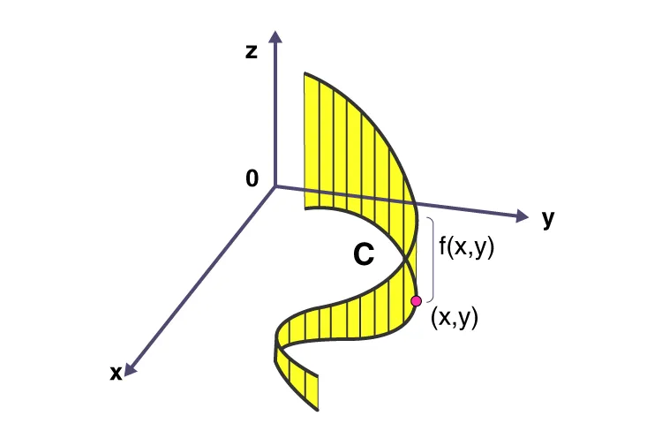

* For **2D curves**, value of line can be calculated by **summing** **values of all the points** it consists of.
* For **3D curves/surfaces**, so can be done by **summing values of all linear stripes** it consists of as shown in the figure above.

**For a given vector field function:**



**Line integral:**

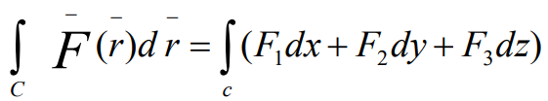

**'C' below integral symbol represents a curve.**

**Where,**



**Parametric Form of Line Integral**

* Representation of the ***line integral*** for a given **parameter/variable**.
* Given ***line integral*** depends on this **parameter**.
* For example, a ***line integral*** may depend on a variable **'t'** representing **time**.

**Parametric representation:**

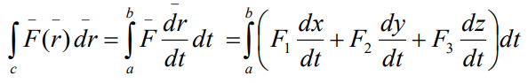

**Line integral for t = a to t = b.**

* **'a'** is called ***initial point***.
* **'b'** is called ***terminal point***.
* Direction from **'a'** to **'b'** is known as **positive direction**.

**For closed curve:**

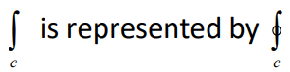

**Irrotational/conservative F:**

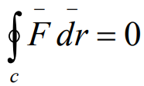

**Thus, *vector* here is independent of path.**

**Scalar Line Integral**

For 2D curve:-

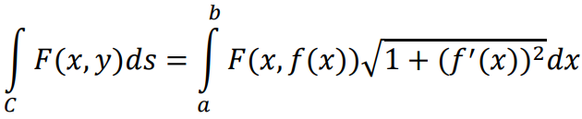

**Where, a <= r <= b (provides an idea for r’s value)**

**And, f(x) means converting y in form of x through *derivatives*. Explained through examples further.**

For 3D curve/surface:-

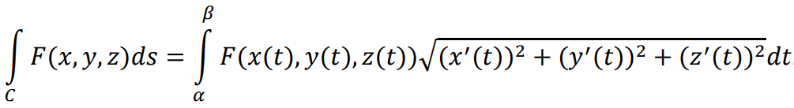

**Where, α <= r <= β & f(x) is given.**

**For example:**



**Solution:**

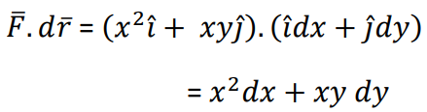

**x = y2 (given parabola)**

**=> dx/dy = d(y2)/dy**

**=> dx/dy = 2y**

**=> dx = 2y dy**



**Surface Integral**

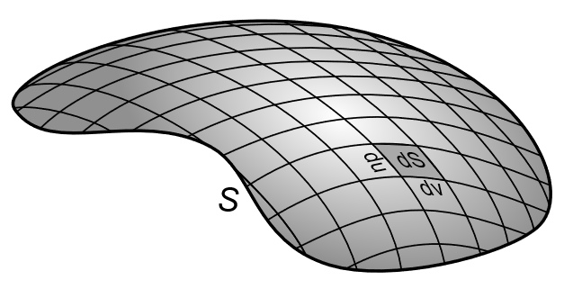

* **Double integration** of a **plane** region.
* Used for **three-dimensional** regions only.
* Applicable on both **scalar** & **vector** fields.

**Surface Integral of Scalar Function**

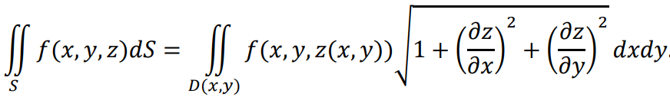

**For example:**

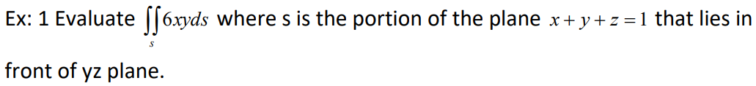

**Solution:**

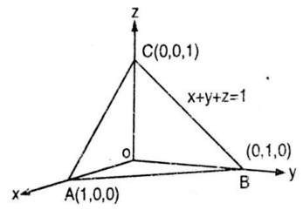

**We are talking about yz plane, so we have to write x in form of valid variables here i.e. y & z.**

**x = 1 – y – z**

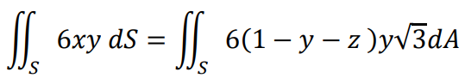

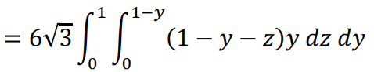

**For knowing from where the root(3) came from, refer to the formula carefully.**

**Surface Integral of Vector Function**

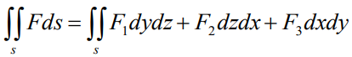

**For example:**



**Solution:**

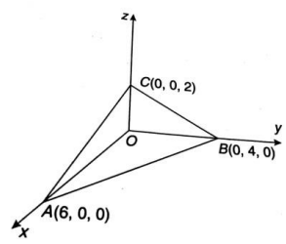

**Because we are not given a particular plane in the question, we can pick anyone.**

**We are picking xy plane for now.**

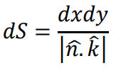 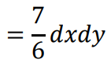

**Equation:**

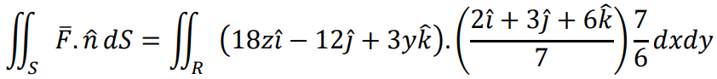

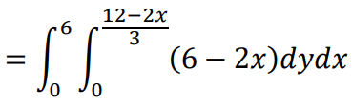

**Green’s Theorem**

* Provides a **behaviour** between **functions** of a **closed curve**.
* We will be applying it for **planes** only.

**For a *closed curve*, if these are continuous:**

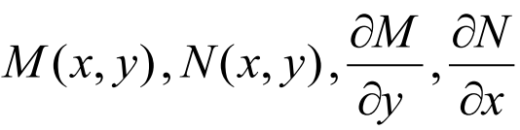

**Then, for xy region:**

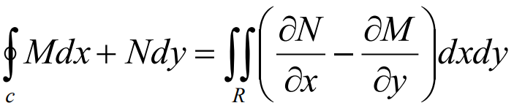

**For example:**



**Solution:**

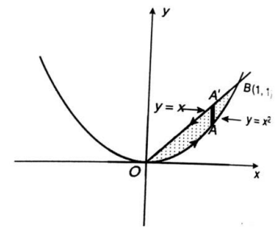



**+**

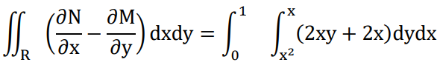

**The initial & terminal points are as per vertical stripes on graph, we can solve the same with horizontal stripes i.e. writing x in terms of y.**

**Gauss Divergence Theorem**

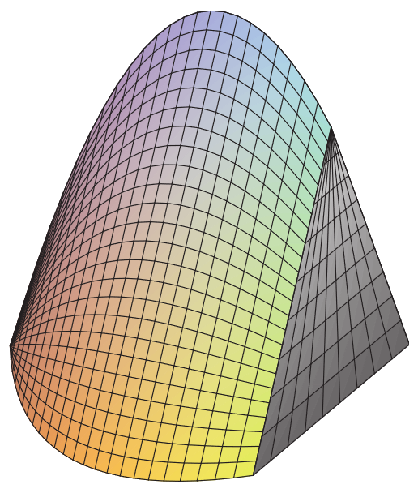

* Used for converting **surface integral** into **volume integral**.
* Used in **vector functions** only.

**Formula:**

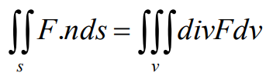

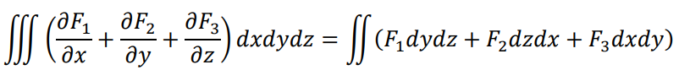

**For example:**



**Solution:**

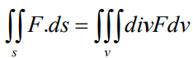

**F = yz i + zx j + xy k**



**So,**



**Stoke’s Theorem**

* Provides us a **relation** between an open solid’s **surface** & its **boundary** lines.
* The **boundary curve** of solid’s open side, is in **anti-clockwise** direction.
* And **unit vectors** are drawn in **outward** direction.

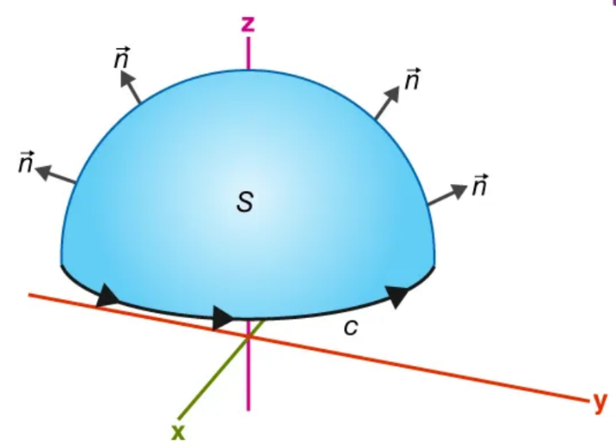

**Formula:**

